Information for the Cambridge Finals on 19th April 2026

Presentations
There will be a presentation for the morning groups at 12.30, and for afternoon groups around 4.00pm....can you make sure that your medal winners are ready to listen to the announcement regarding a march in for the presentations....Please also be aware that we will not be giving out medals ahead of the morning or afternoon presentations.
Last year the presentations for gymnasts towards the end of the medal presentation were affected by some gymnasts leaving the area too soon in a very noisy and excited way......we understand the excitement, but please ask your gymnasts to be respectful of those who have not yet received their medals.

Synchro
The synchro will warm up towards the end of the afternoon presentation on PANELS 1 AND 2.
Please listen for announcements.
The judge panels will be selected from the club's who are competing in the synchro competition and will be published at the weekend.

Car parking
Please use car park 8, map showing location attached below

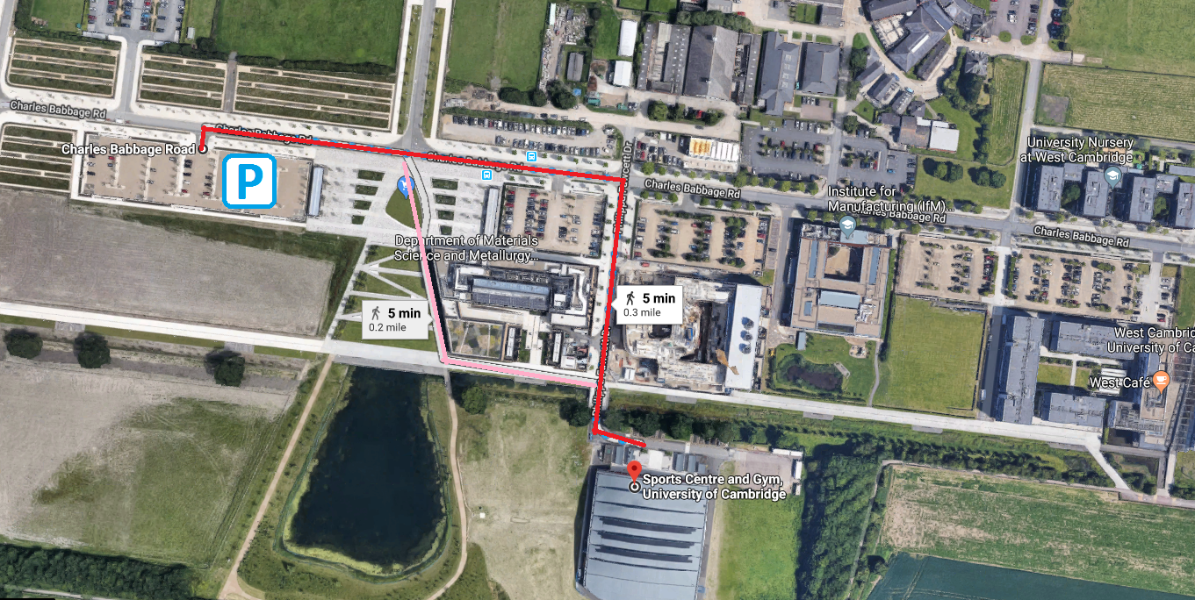
Car park 8
Philippa Fawcett Drive
High cross

