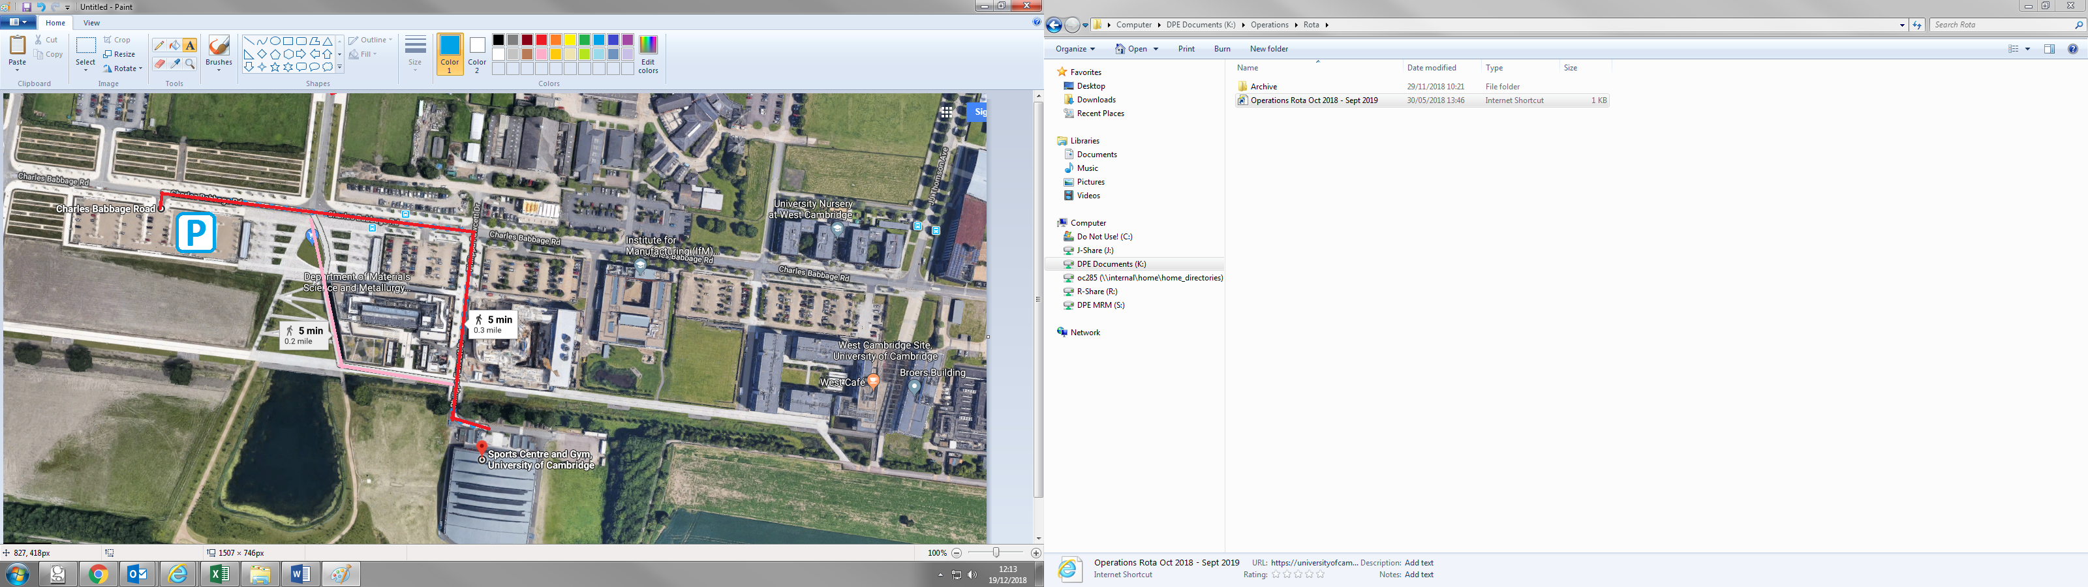

Car park 8

Philippa Fawcett Drive

High cross