Changes to Form or Execution Scoring
For many years we have had 5 judges scoring 'form' or 'execution' where judges consider:
- how tidy the routines are,
- how much the gymnast moves around the bed,
- consistency of height.
In order to ensure that scores reflected the prevailing view as much as possible, whilst 5 scores were always shown only the 3 middle scores counted.
Recent changes announced by FIG (the International governing body) and adopted by British Gymnastics, will see this change quite radically this year. Other judging elements (difficulty and Time of Flight) remain unchanged.

New System
In the new arrangements the role of form judge is split into two elements:
- the tidiness of the routines taking into account, as well, consistency of height, and
- how much the gymnast moves around the bed (called Horizontal Displacement or HD).
Four judges will mark the first of these elements, again with the highest & lowest being discarded. Unless this is your first competition you should be familiar with how these scores appear, an 'average' form score is generally considered to be 7.5 and most form scores tend to be between 7.0 and 8.2 in regional competitions.
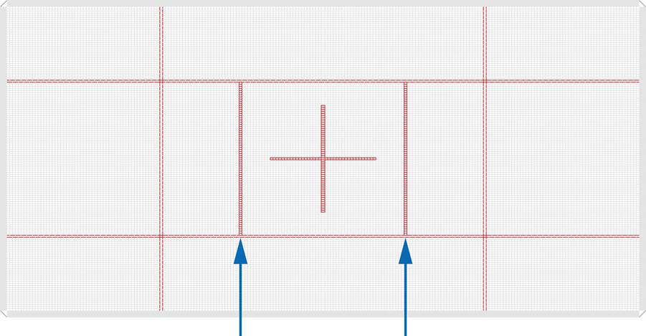
Two judges will mark the second element with the average of their two scores being taken. These judges will make use of the red marks on the trampolines to determine on which segment of the trampoline the gymnast landed, there are two additional lines to those we have seen previously:
Deductions are made as follows:
- 0 if in the 1metre box around the cross,
- 0.1 if in the segment outside the two new lines but still within the old central zone,
- 0.2 if landing in either of the 2 side or 2 end zones, and
- 0.3 if landing in one of the corner zones.
If any part of the feet crosses the lines they are adjudged to be outside. For body landings judges will generally mark it based on where the hips are at the point of landing. It is likely that these scores will be quite a bit higher than form scores so seeing something like the following will not be unusual:
7.3 |  | 7.4 |  | 7.2 |  | 7.5 |  | 8.9 |  | 9.1

In this case the 'form score' would be the sum of 7.4 & 7.3 (14.7) and the displacement score averaged at 9.0 so the overall score for the round would be 23.7.
There will also very occasionally be a Penalty Score given by the chair. That will be most commonly for an 11th move but might be for incorrect dress or for warmup abuse or coach or spotter talking or start of routine "time faults". All these used to be taken off by the execution judges but will now appear as a separate Penalty Score.

